Employee Performance Analysis - INX Future Inc.

Candidate Name : Sahil kamboj

E-Mail : sahilkamboj0077@gmail.com

Project Code : 10281

Exam Country : INDIA

Language : English

REP Name : DataMites™ Solutions Pvt Ltd

Venue Name : Open Project

Assessment ID : E10901-PR2-V18

Module : Certified Data Scientist - Project

Exam Format : Open Project - IABAC™ Project Submission

Project Assessment : IABAC™

Registered Trainer : Ashok Kumar A

**Project Summary**

CEO of INX Future Inc, Mr. Brain wants to understand what factors contributed the most to employee performance and to create a model that can predict if a certain employee will perform as expected or not. The goal of this Data Science Project is to create or improve different performance strategies for targeted employees.

Overall, the implementation of this model will allow management to create better decision-making actions.

As per Project, the following insights are expected from this project.

1. Department wise performances

2. Top 3 Important Factors affecting employee performance

3. A trained model can predict employee performance based on factors as inputs. This will be used to hire employees

4. Recommendations to improve employee performance based on insights from analysis.

# 

**The algorithm used in creating the Machine Learning Model:**

In the given scenario, we have a classifications problem where we required to predict the classification category of the Employees out of three Performance Rating categories given.

Consequently, we use the following Classification Algorithm available in Sklearn Library to solve our problem: -

* Logistic Regression
* Decision Tree Classifier
* KNeighborsClassifier
* Support Vector Classifier(SVC)
* Gaussian Naive Bayes
* Random Forest Classifier ()
* Multi-layer Perceptron classifier (MLPClassifier)
* AdaBoostClassifier
* XGBoost Classifier

In our passage of creating the Machine Learning Model, we found that (after using 10 k-fold cross validation) **XGBoost Classifier() algorithm proves to the winner among others**, both in terms of accuracy and speed.

We use k-fold cross validation because it is **more accurate estimate of out-of-sample** accuracy and **More "efficient" use of data** (every observation is used for both training and testing) than train/test split.

**The most important features selected for analysis :**

Feature importance is very important for reducing overfitting, improving accuracy and reducing training time.

For Feature Importance we use following four Techniques:

1. Univariate Selection (SelectKBest & chi-squared)
2. Feature importance: By using an ExtraTreesClassifier
3. Correlation Matrix with Heatmap
4. Feature Importance: By using a decision tree classifier

After observing the results from the above four Techniques, we have got the **following TOP THREE Feature** affecting Employees' Performance Ratings:

1. **EmpEnvironmentSatisfaction**
2. **EmpLastSalaryHikePercent**
3. **YearsSinceLastPromotion**

And for creating the Machine Learning Model use the following **Top Ten Feature** affecting Employees' Performance Ratings:

**1. 'Env_Satis_NewCat'('EmpEnvironmentSatisfaction')**

**2. 'SalaryHike_NewCat'('EmpLastSalaryHikePercent')**

**3. 'YearsSinceLastPromotion'**

**4. 'EmpDepartment'**

**5. 'ExperienceYearsInCurrentRole'**

**6. 'EmpWorkLifeBalance'**

**7. 'EmpJobRole'**

**8. 'DistanceFromHome'**

**9. ‘Age’**

**10. 'EmpDepartment_Development'**

# **1. Requirement**

# To initiate a data science project, which analyses the current employee data and find the core underlying causes of these performance issues, **we required the Human Resource Data of INX Future Inc. that have data points regarding the targeted Employees.**

# **2. Analysis**

**2.1 Data Set:**

INX Future Inc. has given us the data points of 1200 Employees across six Departments.

- There are 28 columns and 1200 rows in our Raw Dataset.

- INX Future Inc. has Approx. 60% of Employee are Male and 40% are Female

- There are 19 columns, that have numeric value and 8 have non-numeric.

- Data set has a range of features like Employees’ distance from home, Experience years, Employees’ Worklife balance

- As per our Business Problem, Performance-Rating is the Target Variable that we need to Predict.

- Except for EmpNumber, all other Variables provide possible reasonable information for our Machine Learning Model

**2.2 Data Pre-processing Techniques Used:**

Learning Model works on mathematical equations, hence we first need to convert our raw data to an understandable format that can be used for Analysis and sent through a model for predations. And this is called Data Pre-processing.

Used the following Techniques for doing the same:

1. **Deal with categorical Data:**

* Data (String value) are converted to the desired numeric format

1. Binary data:

[ 'Attrition'] are binary in nature and nominal in nature, we use the pandas map functions to convert these to 0 and 1.

1. Ordinal data :

An ordinal variable is a categorical variable that has some order associated with it. for example,['BusinessTravelFrequency'].

We need to transform ['BusinessTravelFrequency'] to set it in the correct order to feed the machine learning model;

We use pandas CategoricalDtype to first convert it order and then get codes for the ordered categories.

1. Nominal data :

Nominal value are a variable that has no numerical importance, such as ['EducationBackground', 'MaritalStatus', 'EmpDepartment','EmpJobRole']

['MaritalStatus', 'EmpDepartment'] , As these are nominal and don't have so many values by category's we can transform it into dummy features.

['EmpJobRole'] is nominal but have high dimensionality of 19, we can't use dummy features, for this we simply use Label Encoder).

* 1. **Feature Engineering**

- ***1. Making Derived Variable* -->** In this process we derived Features from the existing features, to get more attributes of our Target variable i.e Performance Ratings.

For this we use the Pearson Correlation Matrix, to first get the sense of features that have more information about our Target variable i.e PerformanceRatings.

**Then we deduced two new feature namely ['SalaryHike_NewCat'] & ['Env_Satis_NewCat']. These features then proved to be more strongly correlated with our Target variable i.e PerformanceRatings.**

- ***2. Feature Scaling*** ----> The algorithms which use the Euclidean Distance measure are sensitive to Magnitudes. And if features are not scaled to the desired format, it may hamper the predictability power of algorithms.

Since we are not going to apply any algorithms which use Euclidean Distance measure, we don't need Feature Scaling as of now

***- 3. Feature Importance(Selection)***---> This point is already discussed above in Summary.

* *For the data visualization in the following sections, we use* ***Tableau and Python’s Matplolib,Seaborn libraries***
* We use Mean of PerformanceRatings and other features to judge their value because we found that their skewness and kurtosis values are very close to ZERO, hence their distribution very close to Normal Distribution.

**2.4 Department-wise Analysis**

**---Departments---**

-INX Future Inc. has a total of SIX Departments and a total workforce of 1200 Employee as per the given Data set.

- Clearly, **TOP 3 Departments that account for approx. 90% of total workforce** of the INX Future Inc. are 'Sales'(31%), 'Development (30%) , and 'Research & Development'(28.6%)

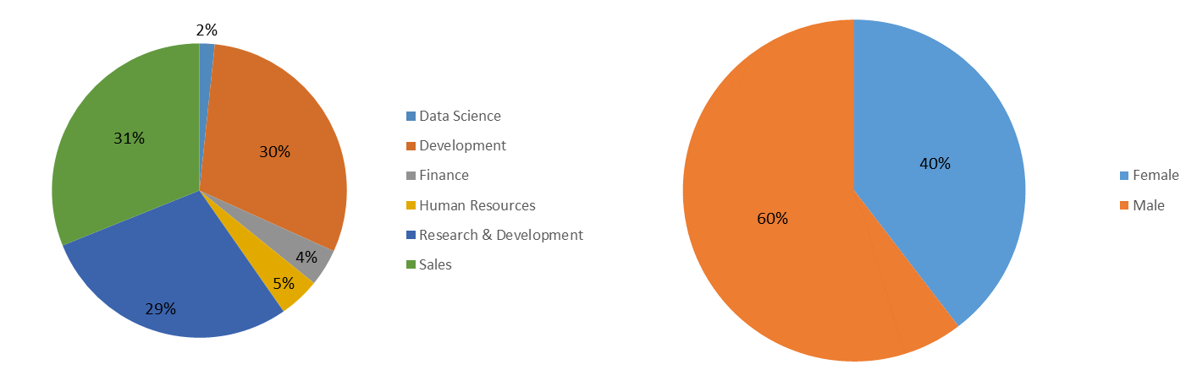

- Other 3 departments that account for approx. 10% of total workforce of the INX Future Inc. are

'Human Resources'(4.5%), 'Finance'(4%),and 'Data Science'(1.6%) only.

**----Employee JobRole----**

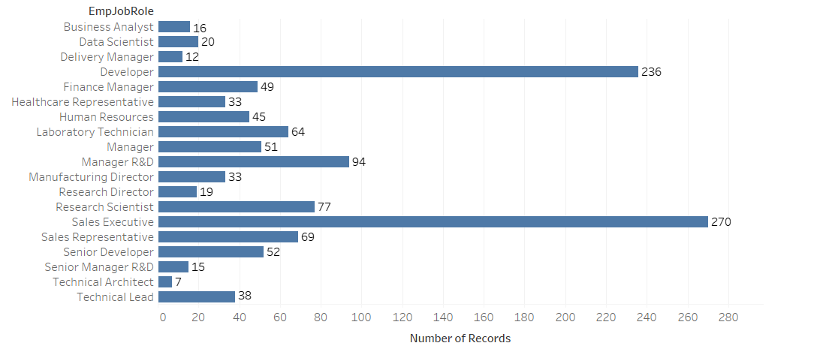

- There are **a total of 19 unique Employee JobRole.**

- Both 'Data Science'(1.6%) and ‘Finance'(4%) departments have one JobRole namely 'Data Scientist' and 'Finance Manager' respectively

- ''Development (30%)' department has six JobRoles namely: - 'Developer','Senior Developer','Technical Architect', 'Business Analyst','Technical Lead', 'Delivery Manager'

- 'Research & Development'(28.6%) department has total 8 JobRoles namely: -'Manager', 'Developer','Senior Manager R&D', 'Laboratory Technician', 'Research Scientist’, ‘Healthcare Representative', 'Research Director', 'Manager R&D',

- 'Human Resources'(4.5%)' department has total of two JobRoles namely: - 'Manager','Human Resources'

- 'Sales'(31%) department has total of 3 JobRoles namely:-'Sales Executive', 'Manager', 'Sales Representative'

**- TOP 3 JobRole that accounts for about 50% of the total workforce** of the INX Future Inc. 'Sales Executive'(22.5%),'Developer(19.6%) and 'Manager R&D'(7.83%).

**---Overall Performance of all Six Departments---**

- Mean 'PerformanceRating' of all the Employees of INX Future Inc. is 2.94

- 'Data Science'(1.6%) and Development(30%) are the only Departments with above mean 'PerformanceRating' of (2.94)

- It is important to note here that 'Data Science' and 'Research & Development' accounts for (1.6%) and (28.6%) of the total workforce of the INX Future Inc. respectively.

- All the other four Departments has performed below the average 'PerformanceRating' of (2.94).

- 'Finance'(4%) has the least mean 'PerformanceRating' of 2.77

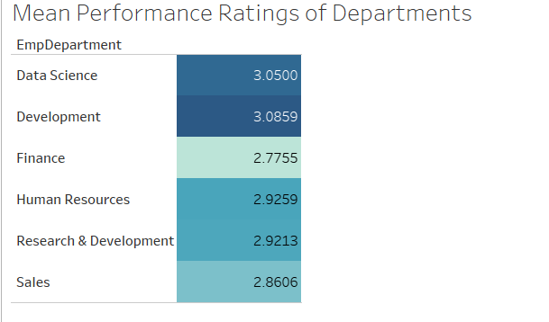

### 

### **----Performance Analysis Of Departments with respect to different factors/Variables-----**

**1. Gender vs PerformanceRating vs Department**

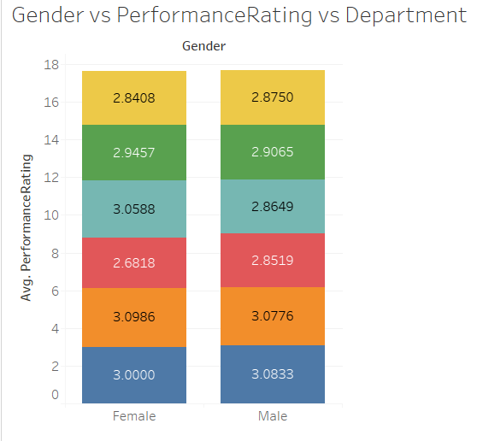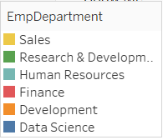

- In 'Finance'(4%) department, Male outperforms the Female with a considerably slight margin. But the opposite is true in the case of 'Human Resources(4.5%)' department. It is important to here that both these department more or less have the same share in the company's total workforce

- In all other four departments, both Male and Female performs similarly with respect to their department's average 'PerformanceRating'

2**. EmpJobRole vs PerformanceRating vs Department**

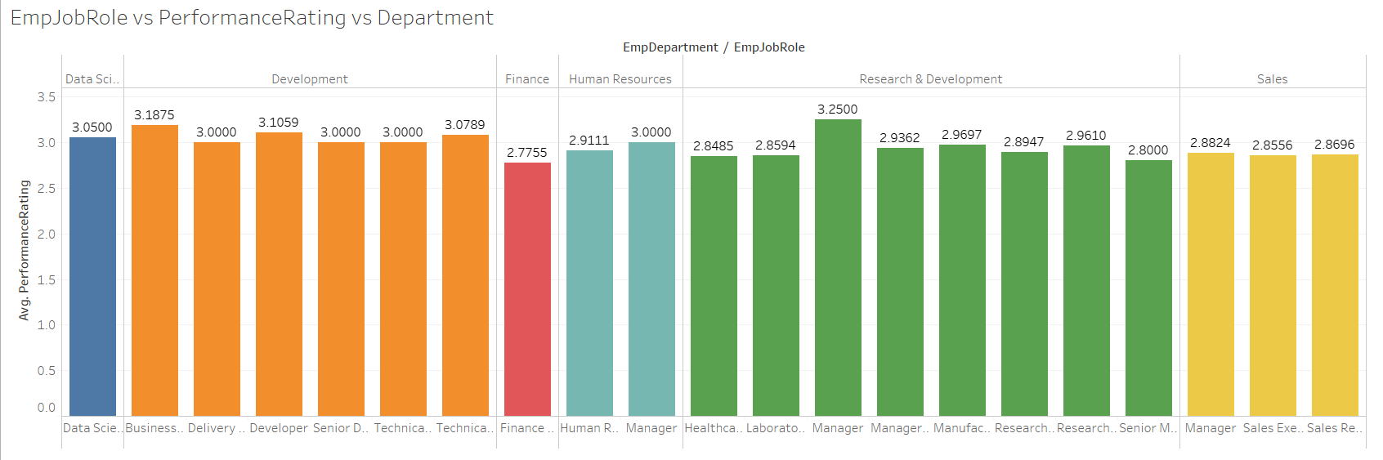



- One striking thing to note here is that even both the Development(30%) and ''Research & Development'(28.6%) ' departments have a more or less equal number of JobRole and equivalent share of Employees in the total workforce of the INX Future Inc. Development(30%) department performs way ahead of ''Research & Development'(28.6%) ' department.

- Hence it can be inferred that **no correlation between the number of EmpJobRole & workforce share one department has and its performance ratings.**

- In ''Research & Development'(28.6%) ' department it very sparkling to see that collectively, employees **who have EmpJobRole Manager are performing even above all other department's EmpJobRoles.**

**3.Attrition vs PerformanceRating vs Department**

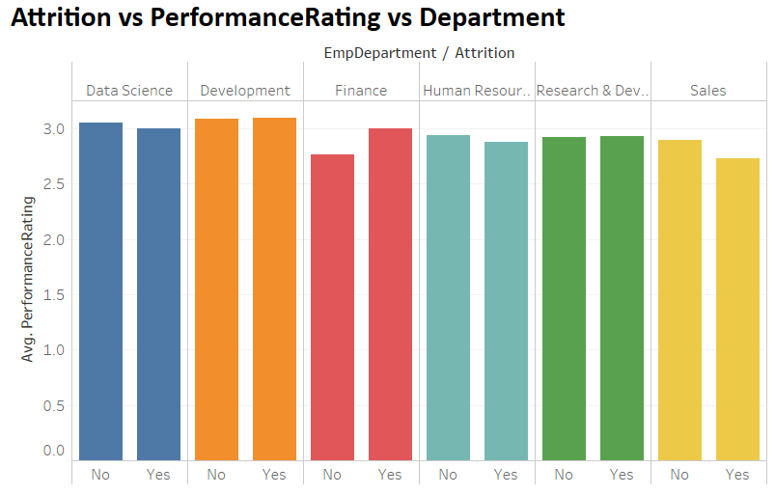

- **TOP 3 Departments that account for approx 90% of total workforce** of the INX Future Inc. namely ('Sales Dept'(31%), 'Development(30%) , 'Research & Development'(28.6%)) have Attrition rate of 23.1%, 16.4% and 14.7% resp. And in all these departments **there was no much big difference between Employee's performance and whether the employee left the company or not.**

- Off course, in some cases of EmpJobRole, it may appear that higher performers are leaving but their Attrition rate is very low and can be treated as an exception.

**- We don't find any concrete pattern that says that Employees who leaving are higher performers.**

**4. EmpEnvironmentSatisfaction vs PerformanceRating vs Department**

- There are Five Ratings given in EmpEnvironmentSatisfaction Index namely: 1(Low),2(Medium),3(High),4(Very High)

- Of these Five Ratings each Ratings in term total employee's workforce accounts for are:- Low(5.3%),Medium(24.5%),High(60.6%),VeryHigh(9.6%)

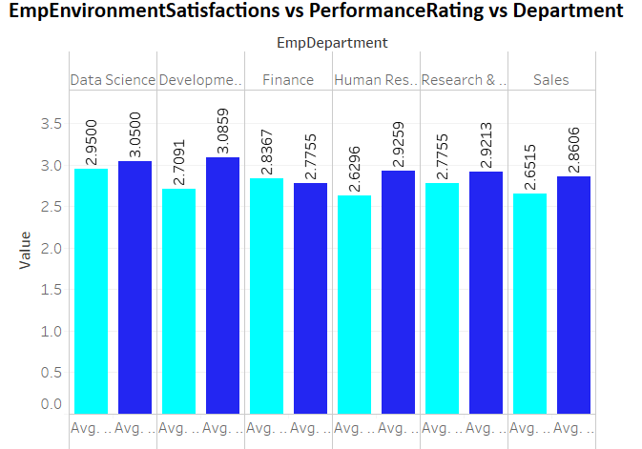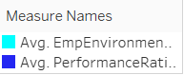

- Mean 'EmpEnvironmentSatisfaction' of all the Employees of INX Future Inc. is 2.71

- Except ‘Human Resources'(4.5%) and 'Sales Dept'(31%) (ignoring the very minute difference in 'Development(30%) department )all other Departments have above Average 'EmpEnvironmentSatisfaction'.

- 'Finance'(4%) department is seen to have the highest mean EmpEnvironmentSatisfaction rating in all of the three Ratings given in the PerformanceRating Index. (There is something very good perception by the Employees of this dept. about their work environment, which can be replicated to other departments as well. This department also has the second-highest mean EmpEnvironmentSatisfaction rating overall after 'Data Science'(1.6%).)

- 'Data Science'(1.6%) department is the clear winner here with mean 'EmpEnvironmentSatisfaction' rating of 2.95 and since it’s also the one of the top-performing department, So clearly there is a POSITIVE correlation between EmpEnvironmentSatisfaction and PerformanceRating

- **One big clear takeaway this analysis is that as the PerformanceRating of all the departments climbs from 1,Good(16.6%) to 2,Excellent(72.8%) and then to 3,Outstanding(11%) among all "EmpJobRole", 'EmpEnvironmentSatisfaction' rating also climbs along with it.**

- Employees with low 'EmpEnvironmentSatisfaction' tend to leave the company more.

- **Employees with high (greater than 2 Ratings)'EmpEnvironmentSatisfaction' tend to leave the company less.**

- **Employee's 'EmpEnvironmentSatisfaction' Ratings also determines whether one leaves the company or not.**

**5.EmpWorkLifeBalance vs PerformanceRating vs Department**

- There are Five Ratings given in EmpWorkLifeBalance namely:- 1(Bad),2(Good),3(Better),4(Best)

- Of these Five Ratings each Ratings accounts in term of total employees are:- Bad(19.1%),Good(20.1%),Bettter(30.6%),Best(30%)

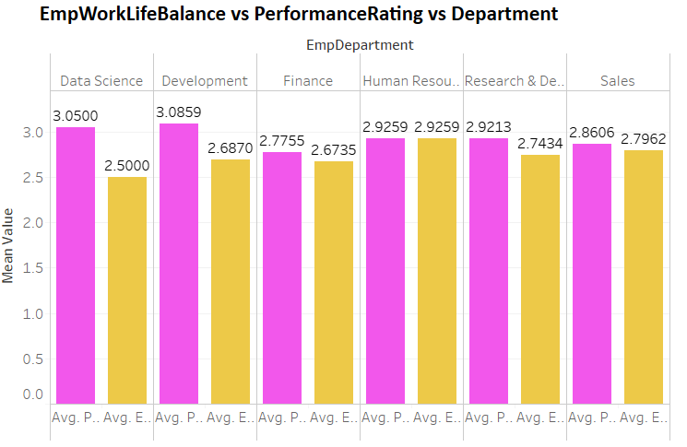

**- Mean 'EmpWorkLifeBalance' of all the Employees of INX Future Inc. is 2.7**

- Although the 'Data Science'(1.6%) department is one of the TOP two performing departments but has the least mean EmpWorkLifeBalance(2.50).This is not as expected as HIGH Performers are generally have HIGH EmpWorkLifeBalance.A similar trend is seen with the Development Dept(30%). This can be explained as since 2, Excellent (72.8%) PerformanceRating accounts for the majority of the rating index overall, Employees in these two depts. are seen to have a decline in EmpWorkLifeBalance Rating When their PerformanceRating increased from 1Good (16.6%) to 2Excellent(72.8%)

- In all the other four Departments, as the PerformanceRating increased from 1, Good (16.6%) to 2, Excellent(72.8%) there is an increase in EmpWorkLifeBalance Rating

- In almost every department among each EmpJobRole, as the PerformanceRating increased from 2,Excellent(72.8%) to 3,outstanding(11%) there is an increase in EmpWorkLifeBalance Rating.

- 'Human Resources'(4.5%) has exactly equal average EmpWorkLifeBalance(2.92) and average PerformanceRating(2.92).

- **Hence overall EmpEnvironmentSatisfaction seems to play a more positive push than EmpWorkLifeBalance with respect to one's PerformanceRating.**

- In deciding one's PerformanceRating, **EmpWorkLifeBalance definitely positively correlated with one's PerformanceRating**

1. **TotalWorkExperienceInYears vs PerformanceRating vs Department**

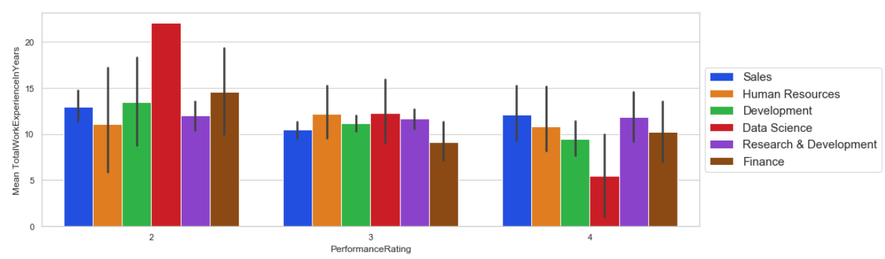

- Mean 'TotalWorkExperienceInYears' of all the Employees of INX Future Inc. is 11.23 years.

- A clear pattern observed in both of 'Development(30%) and 'Data Science'(1.6%) departments, is that as the PerformanceRating goes from 1,Good(16.6%) to 2,Excellent(72.8%) and then to 3,outstanding(11%), the mean 'TotalWorkExperienceInYears' drops.

- **The important observation to note here is that Overall mean 'TotalWorkExperienceInYears' is highly dependable on Employee's JObRole.**

**7. EmpEducationLevel vs PerformanceRating vs Department**

- There are Five Ratings given in 'EmpEducationLevel' namely:-1 'Below College',2 'College',3 'Bachelor',4 'Master',5 'Doctor

- Out of these Five Ratings each Ratings in term of total employees accounts for:-1 'Below College'(12.3%),2 'College'(19.91%),3 'Bachelor'(37.41%),4 'Master'(27.6%),5 'Doctor(3.5%)

- Top Three categories in 'EmpEducationLevel' 2'College'(19.91%),3 'Bachelor'(37.41%) and 4 'Master'(27.6%),that accounts for about 85% of the total workforce of INX Future Inc.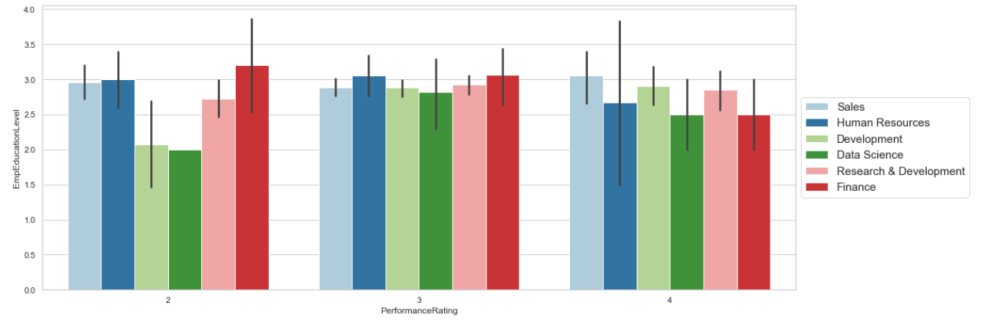

- It is observed that **Employee's EmpEducationLevel is very dependable on his/her JobRole.**

- As the PerformanceRating of all the departments climbs from 1,Good(16.6%) to 2,Excellent(72.8%) (both these ratings account for approx. 90% of the total workforce of the INX Future Inc.), there is an increase in their EmpEducationLevel. (ignoring the very minute decrease in case of 'Sales Dept'(31%) and 'Finance'(4%) department).And we can reasonably generalise it.

- **One clear inference from this analysis is that EmpEducationLevel and PerformanceRating have shown a positive correlation between them.**

**- Hence, one's EmpEducationLevel proves to be one of the key indicators in deciding one's PerformanceRating**

**8. EmpJobInvolvement vs PerformanceRating vs Department**

- There are Five Ratings given in EmpJobInvolvement Index namely:- 1(Low),2(Medium),3(High),4(Very High)

- Of these Five Ratings each Ratings accounts in term total employees are:- Low(5.83%),Medium(24.50%),High(60.33%),Very High(9.58%)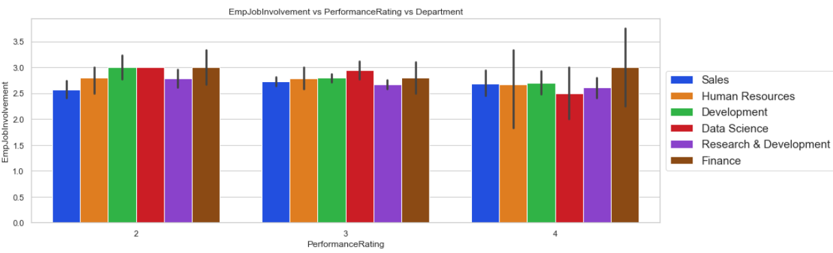

- When PerformanceRating index increased from 1,Good(16.6%) to 2,Excellent(72.8%) except Sales .(31%) Dept. all other departments seems to have decline in EmpJobInvolvement

- And Similarly, when PerformanceRating index increased from 2,Excellent(72.8%) to 3,Outstanding(11%) except 'Finance'(4%) all other departments seems to have declined in EmpJobInvolvement

**- Hence, we can say that EmpJobInvolvement is inversely proportional to PerformanceRating and can be used as a feature in deciding one's PerformanceRating.**

**9. EmpRelationshipSatisfaction vs PerformanceRating vs Department**

- There are Five Ratings given in EmpRelationshipSatisfaction Index namely:- 1(Low),2(Medium),3(High),4(Very High)

- Of these Five Ratings each Ratings in term total employees accounts for:- Low(18.25%),Medium(20.58%),High(31.58%),Very High(29.58%)

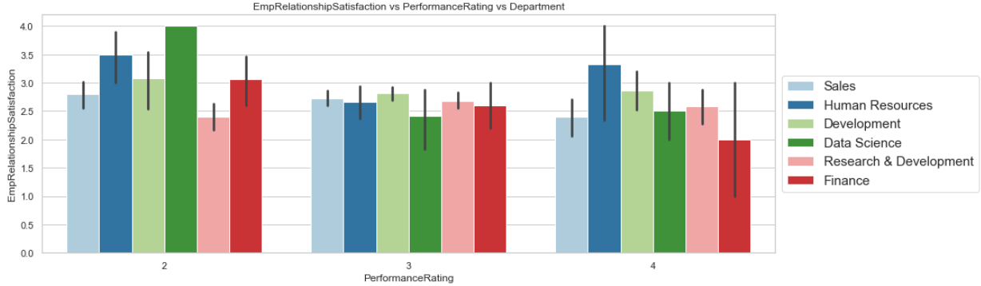

-**EmpRelationshipSatisfaction seems to have very fairly distributed among all the Employees in all its Rating segments.**

- When EmpRelationshipSatisfaction is observed for the Employees of all departments from 1Good(16.6%) to 2Excellent(72.8%) PerformanceRating , it is found that except for 'Research & Development'(28.6%) department, there is a considerable degree of decline EmpRelationshipSatisfaction rating.

- **Since 1Good(16.6%) and 2Excellent(72.8%) PerformanceRating accounts for more than 98% of total PerformanceRating Profile, it is not wrong to say that overall more the Employee is high in the ladder of EmpRelationshipSatisfaction Ratings, less he tends to perform.**

**10. Age vs PerformanceRating vs Department**

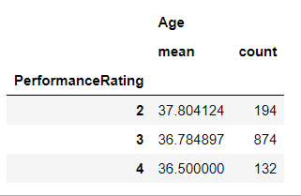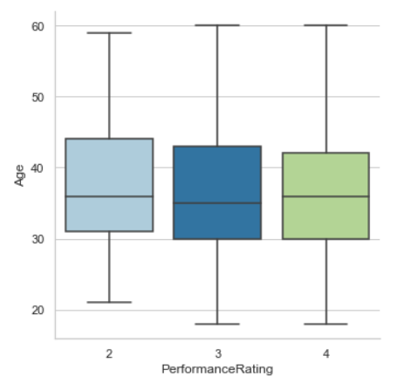

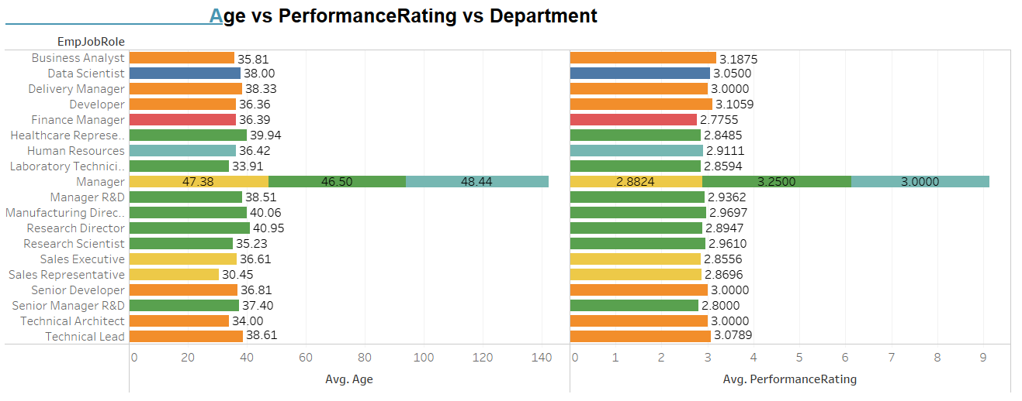

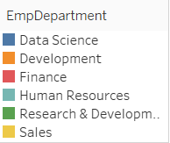

- The mean Age of the total workforce of INX Future Inc. is 36.91 years.

- Although, Age is somewhat susceptible to one's EmpJobRole but, **if we see the greater picture, as the Performance-Ratings climbs from 2 to 4 ,we can say that younger Employees tend to perform better than olders'.**

**11. YearsSinceLastPromotion vs EmpDepartment vs PerformanceRating**

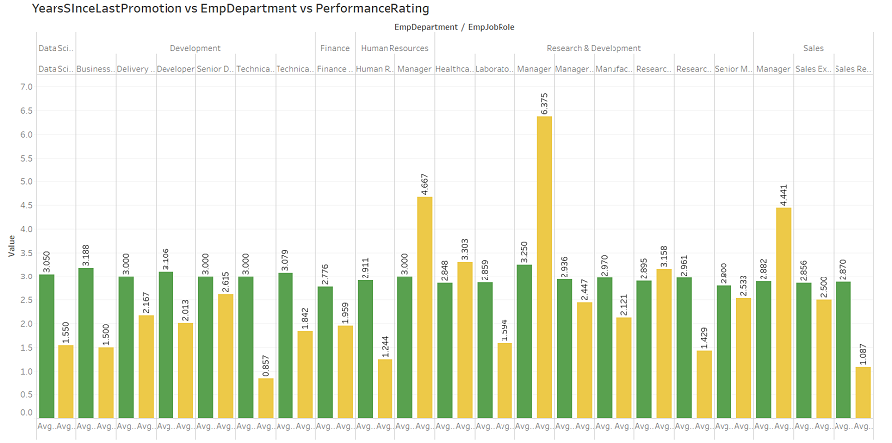



- Mean YearsSinceLastPromotion of all the Employees of INX Future Inc. is 2.19.

- The important observation to note here is that Overall Average ' YearsSinceLastPromotion is highly dependable on Employee's JObRole.

- **Generally, it is found that in each department, more the numbers of YearsSinceLastPromotion more ones tend to perform low.**

- A similar trend is seen in the case of ExperienceYearsInCurrentRole, more the numbers of YearsSinceLastPromotion more he tends to perform low.

- **YearsSinceLastPromotion & ExperienceYearsInCurrentRole & seems to have very positively correlated with each other**

**12. "OverTime" vs EmpDepartment vs PerformanceRating**

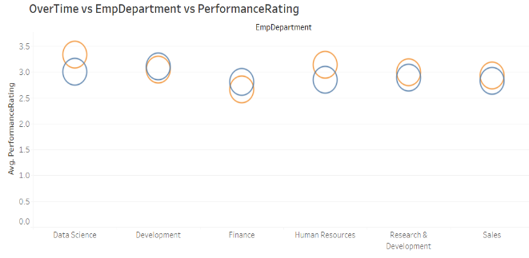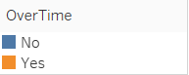

- In almost all departments (expect 'Development (30%) & Finance (4.5%) and that too in 'Development (30%) gap in very diminishing), Employees who had positive OverTime tend to have higher PerformanceRating.

- **Hence, we can say that OverTime plays an important role in deciding one's PerformanceRating.**

# Analysing some of the important Variables with respect to Performance

1. **'DistanceFromHome' vs 'PerformanceRating'**

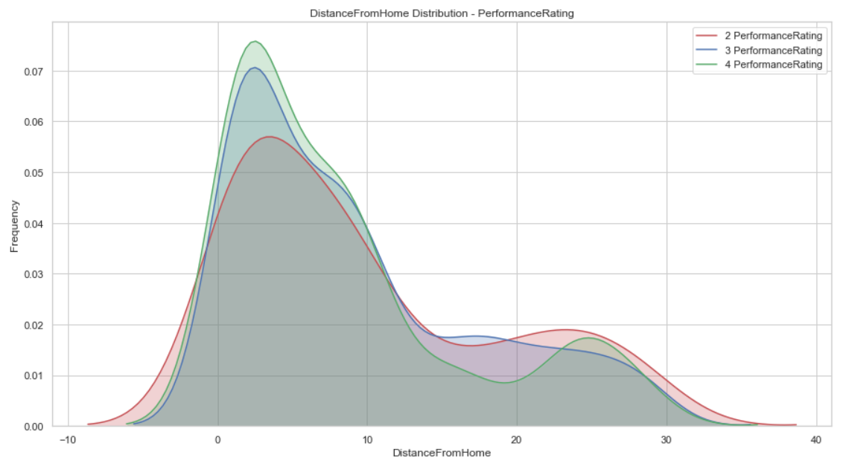

- There is a Bi-modal PerformanceRating distribution (for all the three ratings) for the employees of INX Future Inc.,

- Employees who had less DistanceFromHome (less than~10 distance units) tend to have higher PerformanceRating.

- Employees who had too many hours of work (greater than ~10 distance units) tend to have low PerformanceRating.

**- It might be not wrong to say that Employees who live close to their Company, able to manage their personal and professional life balance better since they get more time to spend with their family than those who live farther.**

1. **Age vs PerformanceRating**

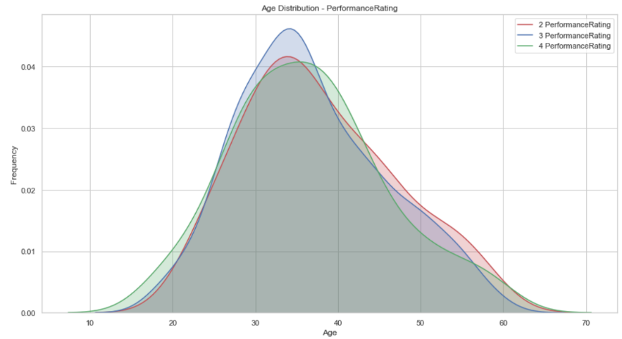

**- Employees less than 30 and between 37 – 44 year old (at better position because of accurate blend of age and experience) relatively perform better than others.**

**-** As we have seen earlier during departmental analysis**, younger minds tend to perform higher than older ones.**

**3. EmpHourlyRate vs PerformanceRating**

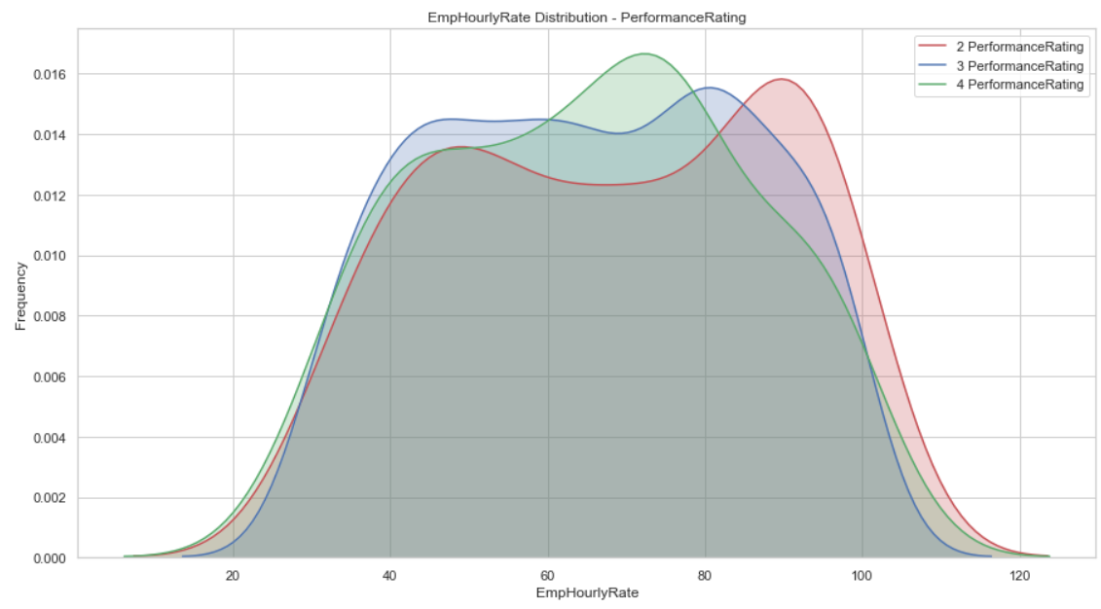

- Employees who had EmpHourlyRate (in the range between 45 - 78) tend to have higher PerformanceRating.

- Employees who had EmpHourlyRate (greater than 78) tend to have lower PerformanceRating.

- **EmpHourlyRate (in the range between 45 - 78) seems to be the optimal EmpHourlyRate in which Employees performs better than other EmpHourlyRate ranges**

**4.NumCompaniesWorked vs PerformanceRating**

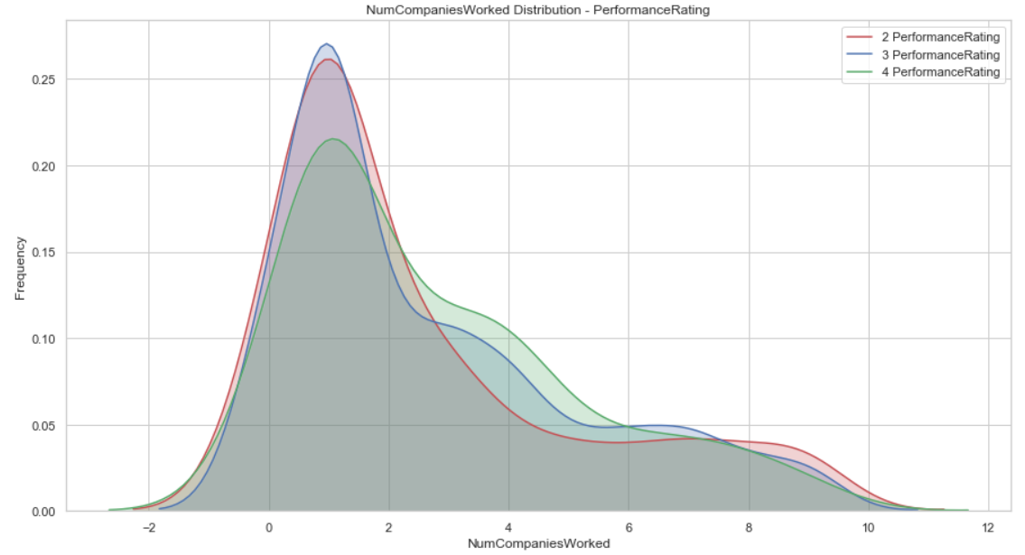

- There is a sweet spot for employees that have performed well, ( 2<NumCompaniesWorked<6 )

- **This sweet spot can be explained as, at this sweet spot Employees has the right blend of Age and Experience, which enables them to perform better.**

**5.TotalWorkExperienceInYears vs PerformanceRating**

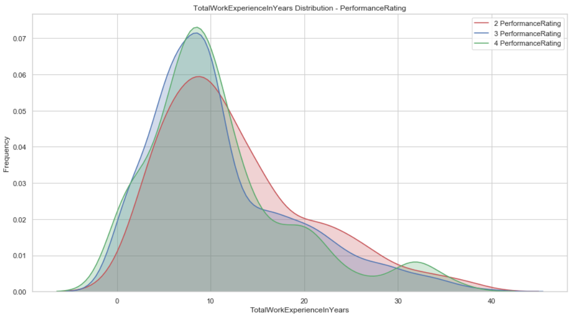

- There is a multi-modal PerformanceRating distribution (for all the three ratings) for the employees of INX Future Inc.

- **Overall Employees, who had less than ~14 years TotalWorkExperienceInYears tend to have higher PerformanceRating.**

- **It is also observed that Employees who had greater than ~31 years TotalWorkExperienceInYears seem to perform somewhat good but their frequency is quite low. It may possible for some domains higher.**

- Employees’ TotalWorkExperienceInYears says a lot, it tells Employees’ Age and Professional experience and many other attributes of Employees’ life.

**6."YearsSinceLastPromotion" vs 'PerformanceRating'**

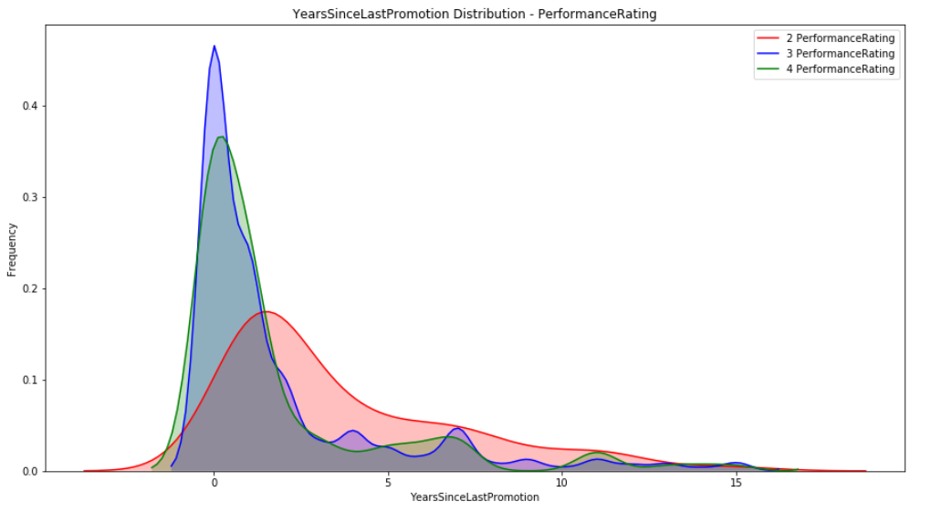

- Earlier it is found that in each department, more the numbers of YearsSinceLastPromotion more ones tend to perform low.Similar trends prove to be right here.

- If an employee has less than 2 YearsSinceLastPromotion, he is more likely to perform well than others.

**Recommendations to improve the employee performance based on above insights from analysis**

**Performance Improvement Plans**

After analysing the number of different the trends and patterns, we have divided the **Recommendations into Three Categories for improving the employee performance namely:**

* **Business Problem:**

Get insights from the dataset of INX Future Inc., to find-out why the employees' Performance Index is not as per expectations and what can be done to improve the current situation.

**1. During the Hiring Process**

**2. After the Hiring Process**

**3. During Penalization the non-performing Employee**

**1. During the Hiring process**

**a. EmpEducationLevel(EducationBackground):**

While examining the EmpEducationLevel vs PerformanceRating vs Department, we found a clear positive correlation between EmpEducationLevel and PerformanceRating.

Hence it is good **to raise the standard of the company policy regarding EmpEducationLevel & EducationBackground while hiring the Employee than earlier.**

**b. NumCompaniesWorked(Age/TotalWorkExperienceInYears)**

The employee worked in greater than 2 and less than 6 companies are found to have a unique mix and blend of Age/TotalWorkExperienceInYears, that they performed better than others.

**Hence while hiring, this sweet spot of ( 2<NumCompaniesWorked<6 ) for employees needs to be taken into consideration.**

**c.     DistanceFromHome**

Employees who had less DistanceFromHome (less than~10 distance units) tend to have higher PerformanceRating. This might be because of their higher energy, motivation, better **personal and professional life balance(WorkLifeBalance), that enable them to have higher performance.**

**Human Resource policy of INX Future Inc. can be amended so that only those candidates are shortlisted for hiring that less distance from home than others of similar profile and have other suitable sets of Qualifications.**

**3. After the Hiring Process**

It involves the steps that can be implemented to improve the work culture of the company that is in harmony with the performance capabilities of the Employees.

**a. EmpEnvironmentSatisfaction:**

We know that INX Future Inc, (referred to as INX ), is one of the leading data analytics and automation solutions providers with over 15 years of global business presence. And INX human resource policies are considered as employee-friendly and widely perceived as best practices in the industry**. But as per the recent scenario, their employee performance indexes are not as healthy as expected.**

One of the TOP THREE factors that have very high correlations with their employee performance indexes is “EmpEnvironmentSatisfaction”. If INX Future Inc. able to improve this feature, it helps a lot to regain or exceed its expected employee performance indexes.

**It can be improved by making corrections in the following segments:**

1. **A respectful treatment of employees at all levels**

**It’s high time for**INX Future Inc. to reach out to employees, find common ground with each of them and earnestly attempt to see their points of view. **Most importantly, managers should show respect for their employees’ perspectives.** It helps to raise employees’ self-confidence and they feel more connected to the common goal of the company, that it wants to achieve.

1. **Job security**

INX Future Inc. should aggressively try to keep the **lines of communication open with Employees to reassure them that you value their contributions to the organization**. Not only will it boost their confidence and make them feel more secure about their position, but it will also foster a more trusting workplace environment.

1. **Trust between employees and senior management**

If your staff doesn’t trust its management team, employees might wind up withholding valuable market and sales information in an effort to gain leverage over what they perceive to be a hostile working environment.

**More Trust and greater Autonomy by the**senior managers to its staff helps to build the gap and raise morale and productivity of Employees in the long run.

1. **Overall benefits**

As we know,INX Future Inc , (referred as INX ) , is one of the leading data analytics and automation solutions providers with over 15 years of global business presence. **It may possible that competitors are flashing good salaries at talent to lure them away from your business**. ( in some cases of EmpJobRole, it found that higher performers are leaving)

**Offering unique benefits, such as flex work-time, recognition and rewards could give your company the upper hand in the competitive environment.**

**EmpEnvironmentSatisfaction is one of the TOP THREE factors** that have very high correlations with our Target variable i.e Performance-Ratings. But it is much inter-connected to a number of sub-factors as discussed above.

***INX Future Inc. needs to inculcate these above indicators, sub-factors, and agents that ultimately help to improve Employees’****EmpEnvironmentSatisfaction.*

3.   **During Penalizing the non-performing Employee**

We are supposed to provide clear indicators of non-performing employees**, so that any penalization of the non-performing employee if required, may not significantly affect other employee morals.**

As we found that there is no difference between the overall Mean Performance Rating of Male and Female. And more or less, there not many ups and downs between attributes of Male and Female that decide their Performance Rating.

Hence, both have following similar indicators of non-performing Employees.

The following **Employees’ Penalty Meter**proves to very useful in deciding Employee’s future fate and helps the company to achieve its expected goals.

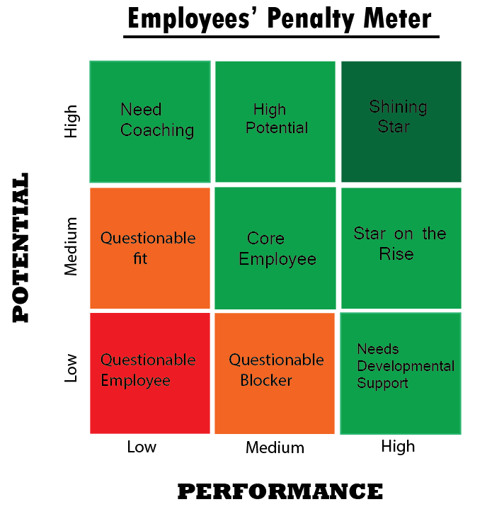

**If Employee is in any of Red and Orange block**, CEO of INX Future Inc, Mr. Brain, and management may think and purpose to **take strict action against the targeted Employee.**

**If Employee is in any of Light Green shades’ blocks**, CEO of INX Future Inc, Mr. Brain, and management may think of **taking a corrective course of action** as discussed above **to improve** their the Performance-Rating of the**targeted Employee.**

**If Employee is in Dark Green shades’ block**, CEO of INX Future Inc, Mr. Brain, and management may think suitable rewards and bonuses for the **targeted Employee.**

* To decide which block the target Employee fits**, the following indicators need to be looked upon and evaluate their current position.**

**Performance:**

**1.EmpLastSalaryHikePercent:-**

It is one of the TOP THREE factors that have very high correlations with their employee performance. If Employee gets high EmpLastSalaryHikePercent but not performing as expected.

Here, our derived variable be beneficial, we found that SalaryHikePercent of 19% is dividing the dataset into two categories, so we created a new derived variable namely ['SalaryHike_NewCat'], **if an Employee is in categories 1 he/she is less likely to perform well or if an Employee is in categories 2 he/she is more likely to perform better.**

2. **EmpRelationshipSatisfaction**

**Since 1Good(16.6%) and 2Excellent(72.8%) PerformanceRating accounts for more than 98% of total PerformanceRating Profile, it is not wrong to say that overall more the Employee is high in the ladder of EmpRelationshipSatisfaction Ratings, less he tend to perform.**

**3.OverTime**:

If an Employee has positive(Yes) Overtime he/she is more likely to perform well than who has negative (No) Overtime.

Overtime helps to decide his/her Performance-Rating.

**4.EmpHourlyRate:**

EmpHourlyRate **(in the range between 45 - 78) seems to be the optimal EmpHourlyRate, in which Employees performs better than other EmpHourlyRate ranges**

If an Employee has EmpHourlyRate **in the range between 45 – 78** ,he/she is more likely to perform well than other.

**Potential:**

**1. Age**

As we have seen earlier during departmental analysis, **younger minds tend to have higher potential and adaptive nature** to perform higher than older ones.

If **an Employees less than 30 and between 37 – 44 year old (at better position because of accurate blend of age and experience) is more likely perform relatively better than others.**

**2. YearsSinceLastPromotion**

YearsSinceLastPromotion is one of the TOP THREE factors that have very high correlations with our Target variable i.e. Performance-Ratings.

Generally, it is found that in each department, **less the numbers of YearsSinceLastPromotion more one's tends to perform well.**

**If an employee has less than 2 YearsSinceLastPromotion, he is more likely to perform well than others**

**Hence, it can be used to judge the Employee’s Potential profile, followed by apt action.**

3.   **Psychology and Attitude**

Try to understand Employees’ **Psychology** and Attitude**. If an Employee has a Positive Attitude and right Psychology,**he/she is always better equipped and **higher potential to perform well.**